# WELCOME

Ms.

Julia

FEHLER

Flight Arrival Date: 17 Mar 2019 Flight Arrival Time: 07:10 Flight Number: TG475

Homestay Address: Elizabeth KARABELAS, 5 Easton Avenue, Sylvania, NSW, 2224

Mobile: 0431 152 159

Once you arrive at Darwin Airport

When you come out of Customs, please wait for your host outside the gate (check the map circled in red) where your driver/host will wait for you there

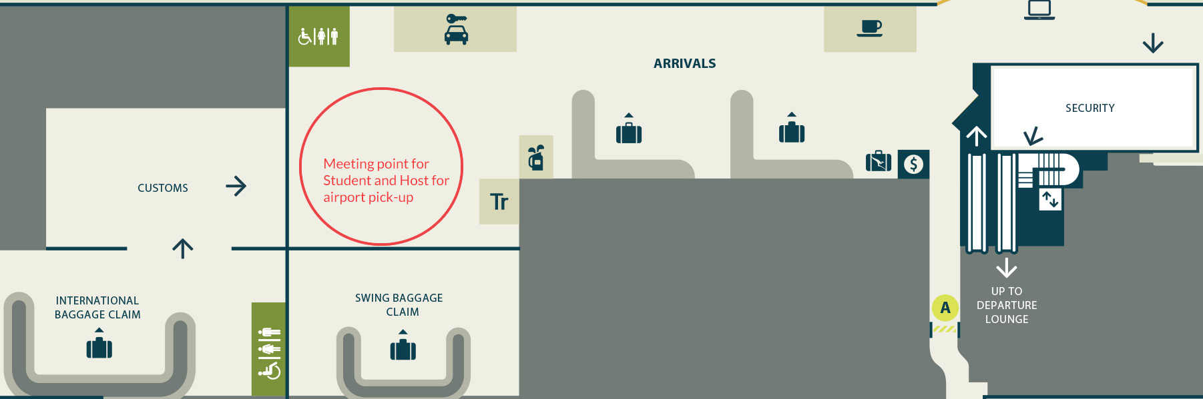

In case of Emergency please contact:

Your Host: 0415 375 005

Global experience Emergency Number: (+61) 430 008 448

PLEASE DO NOT LEAVE THE AIRPORT, WAIT FOR YOUR DRIVER